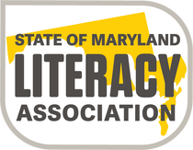

YOUNG AUTHORS’

CONTEST COVERSHEET
2019 – 2020

Please print clearly or type. Information will be used for publication.

Student/Author’s Name: | Student’s name as it should appear in the publication
Home Address: | (Street, city, state. zip)

Home Phone:

Email Address:

School Name/ Address:

(Full Address with zip code)
Grade:  Teacher: First & Last Name | Grade: ______  Mr., Mrs., Ms. (circle one) _______________________________

Teacher Email:

*Must be included
Local Reading Chapter: | Howard County
Title of Entry: | Title:  Delete one: POEM (P) SHORT STORY (SS)

Parent Permission

I, _________________________________________, attest to the authenticity of my child’s
Print first and last name
original work and give permission for SoMLA representatives to publicize my child’s name and reproduce his/her work in an anthology of writing in the event (s)he becomes a state winner.

Parent Signature:____________________________________Date: ______________

***************************************************************************
For local chapter coordinator’s use only:
Entry Type & Judging ID Number (ie-“P1” or “SS4”):

