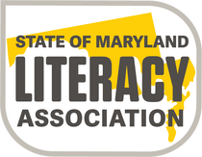
Elementary School
Young Authors’ Contest
2019-2020

NEW!

Who: Students in Grades 1-5
What: Write a poem or short story
- Entries must be original work.
NEW!
- All entries must use no smaller than
12 point font in Times New Roman.
- Short story entry must range between 100-400 words (gr. 1-2) and 300-800 words (gr. 3-5).
- Poem entry will consist of a single poem, any style, and must range between 25-150 words (all grade levels).
- Entries must not include graphics.
- Each entry must include a completed cover sheet signed by the student author’s parent.

For additional details and guidelines,
contact your local literacy association Young Authors’ Contest Chairperson: Maria Moy, Howard County Literacy Association maria_moy@hcpss.org

Entries due to Joanna Kasda at DLES by
Friday, December 6th, 2019

(Winning entries will be forwarded from local chapters to SoMLA by January 1, 2020.)

